**28.** **JUNIT TESTING TO CHECK WHETHER THE GIVEN USERNAME IS VALID OR NOT**

M.Anusha

192124420

**AIM :**

To Perform junit Testing to Check Whether the given Username is Valid or not.

**PROGRAM** :

**package** sse;

**import** **static** org.junit.Assert.assertEquals;

**import** java.util.Scanner;

**public** **class** username

{

**public** **static** **void** main(String [] args)

{

Scanner in=**new** Scanner(System.***in***);

System.***out***.println("enter the user name");

String str1=in.nextLine();

System.***out***.println("Reenter the user name");

String str2=in.nextLine();

assertEquals(str1,str2);

}

}

**OUTPUT:**

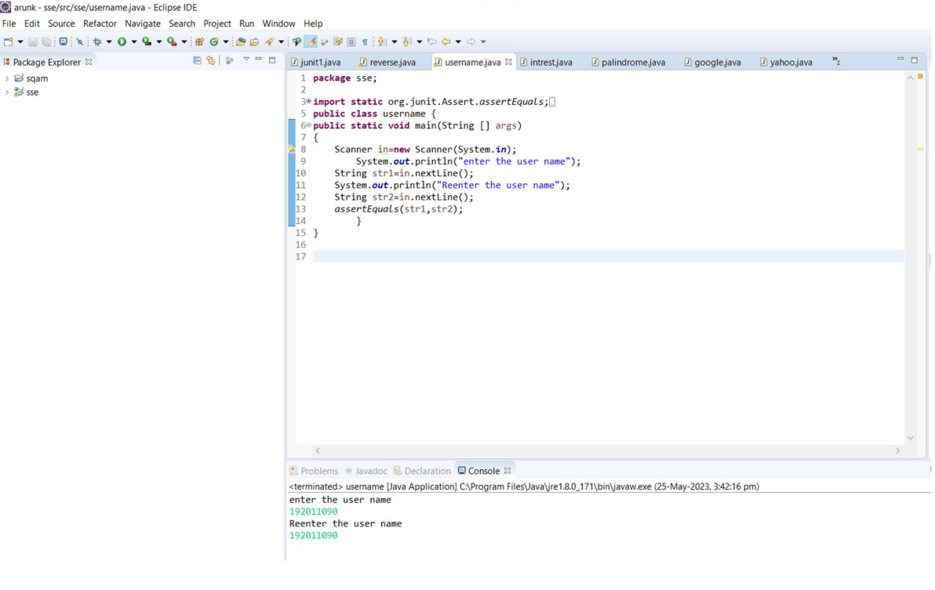

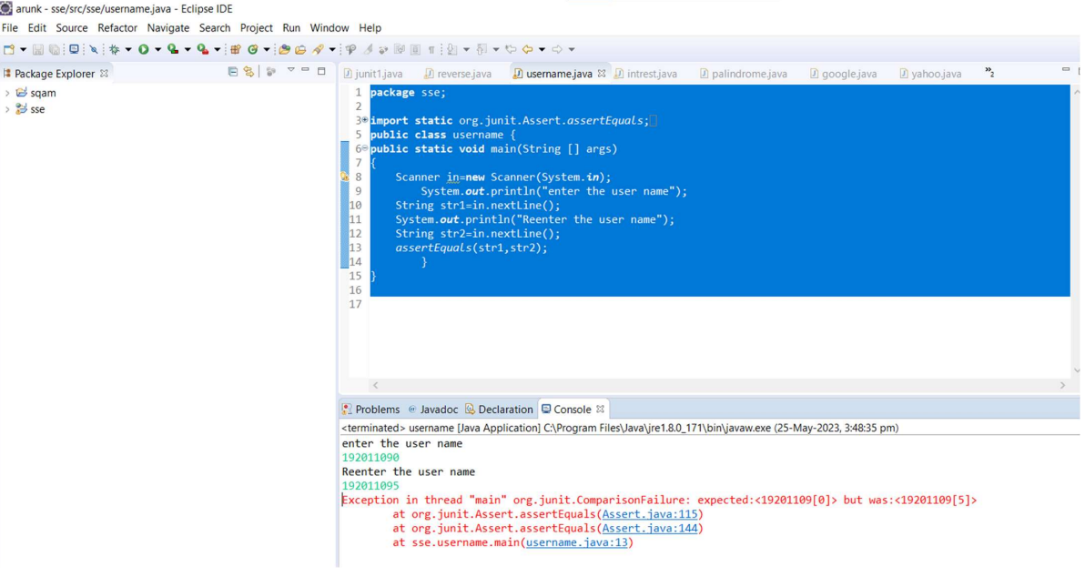

**RESULT:**

Hence the junit Testing to Check Whether the given Username is Valid or not performed successfully.